# Language Detection Web Application – Duck Soft Works § Co.

# US 4 – As a user, I want to cancel a task that is currently being processed

## 1. Requirements Engineering

### 1.1. Customer Specifications and Clarifications

### Q: What does it mean for the task to be "expressly canceled"? R: It means that the user “expressly” cancels the task (by clicking a cancel task button on the application frontend).

### 1.2. Acceptance Criteria

Cancel method in order to complete cancellation of task language analysis.

It is only possible if the task is still with a “Processing” status.

### 1.3. Found out Dependencies

In order to fulfill the cancellation method, one task with status “Processing” must exist. That means that language analysis is still in process.

### 1.4. Input and Output Data

In order to cancel a task, the user must provide the task id.

### 1.5. System Sequence Diagram (SSD)

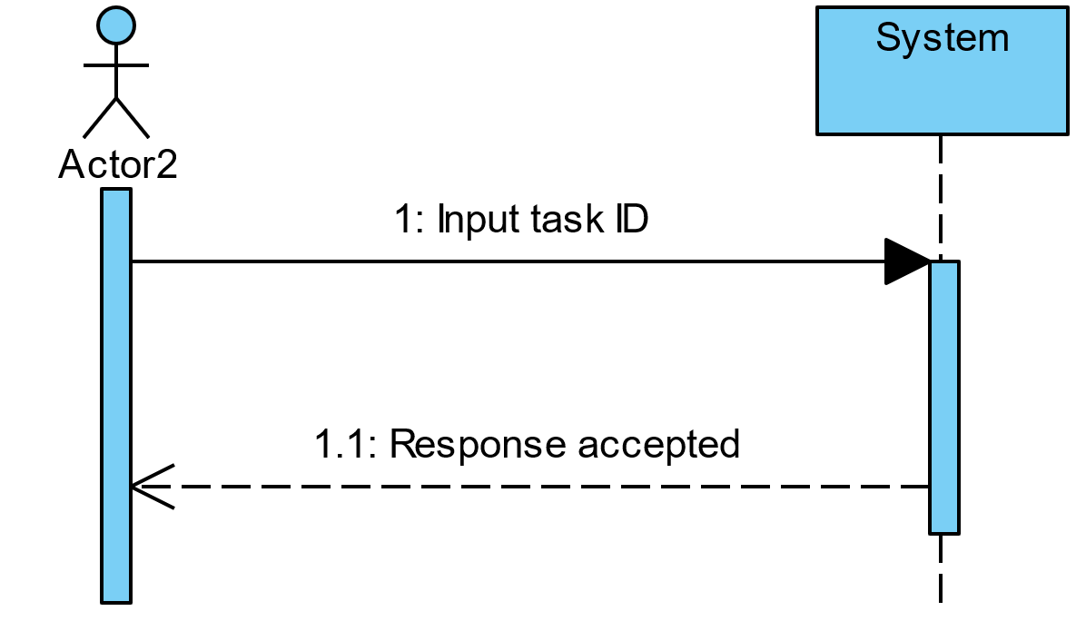

## 2. OO Analysis

### 2.1. Relevant Domain Model Excerpt

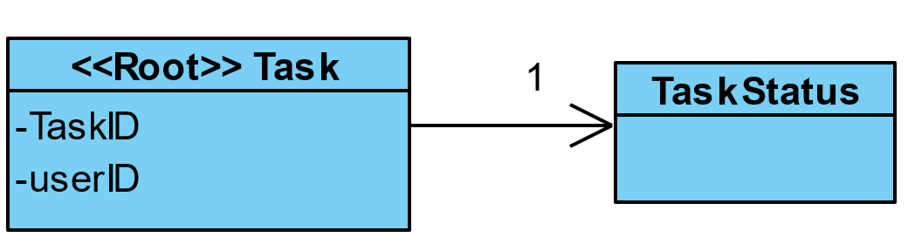

## 3. Design - User Story Realization

## 3.1. Sequence Diagram (SD)

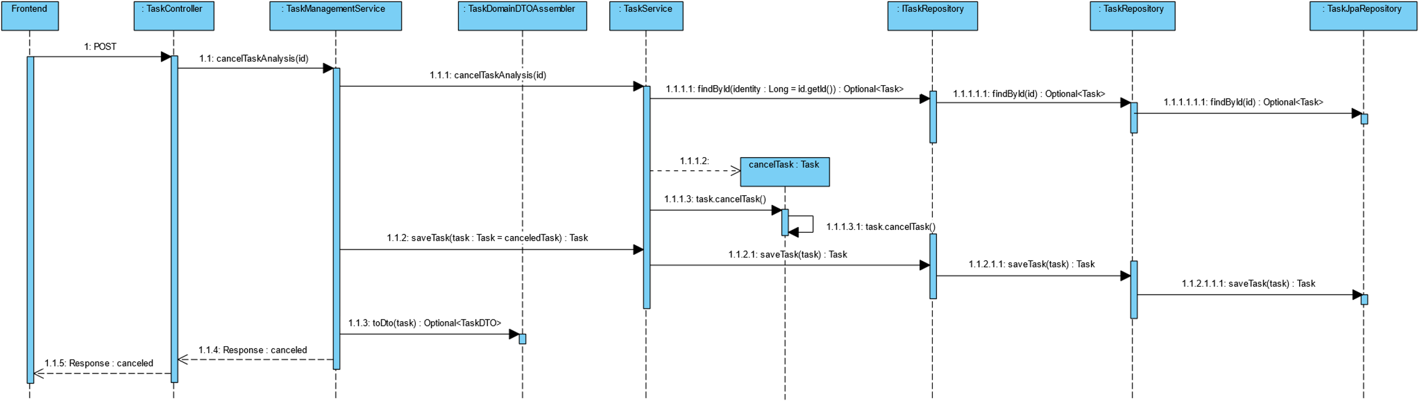

## 3.2. Class Diagram (CD)

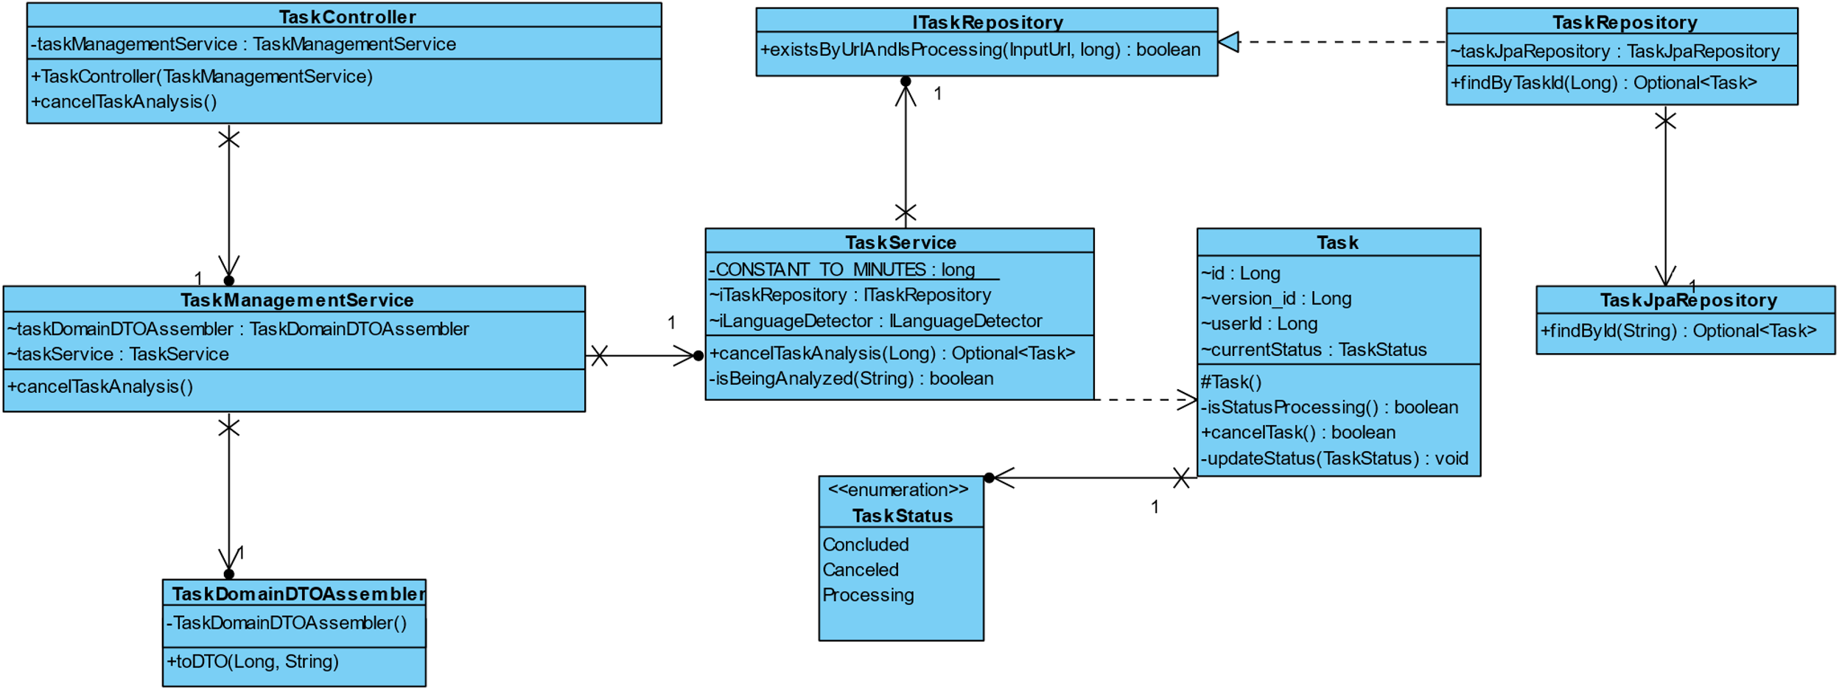

# 4. Construction (Implementation)

As we faced several problems when trying to cancel an ongoing thread, construction of this user story was not easy. After trying to interrupt or kill one thread with several methodologies without success, we chose to just change the task state from **Processing** to **Canceled** directly through a save in the database. For this, we use a Task copy constructor to modify the object's state and then store the information.

# 5. Integration and Demo

To integrate this with the rest of the application, before modifying the object's state to **Canceled**, we need to verify that the task with the ID passed in the argument actually exists.

# 6. Observations

We are aware that this implementation is not ideal, however, given the problem we face of not being able to interrupt the asynchronous process of language analysis, we chose to solve it this way.

We are aware that there is a performance issue as the request to cancel the analysis does not interrupt the process and, therefore, continues to use the machine's resources.